1️⃣ Hierarchical Clustering (Big Picture)
What is Hierarchical Clustering?
Hierarchical clustering is an unsupervised learning technique that builds a tree-like hierarchy of clusters, instead of producing just one flat partition.
There are two types:
- Agglomerative (Bottom-Up) ✅ (most common)
- Divisive (Top-Down) ❌ (rare in practice)
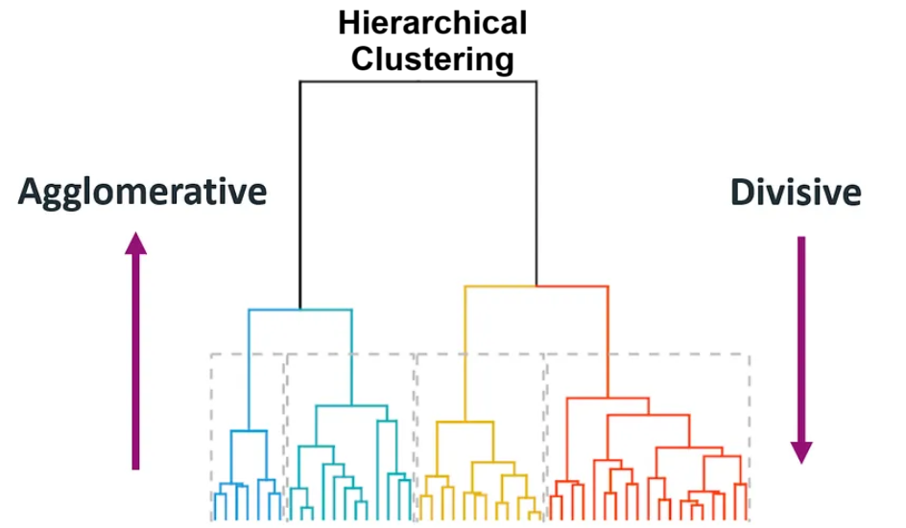

Key Characteristics
- Does not require K beforehand
- Produces a hierarchy of clusters
- Very interpretable
- Works best for small to medium datasets

Real-Life Intuition
Think of family trees:
- Individuals → families → communities → cities → states

Mathematical Idea (High Level)
- Uses a distance matrix
- Iteratively merges or splits clusters
- Distance is computed using linkage methods

2️⃣ Agglomerative Hierarchical Clustering (Bottom-Up)
Definition
Agglomerative clustering starts with each data point as its own cluster, then repeatedly merges the two closest clusters until only one cluster remains.

Algorithm Steps
- Start with N clusters (each point = 1 cluster)
- Compute distance matrix
- Merge the closest clusters
- Update distances
- Repeat until one cluster remains

Linkage Methods (VERY IMPORTANT)
Linkage | How distance is calculated | Behavior
Single | Min distance between points | Chain-like clusters
Complete | Max distance between points | Compact clusters
Average | Avg distance | Balanced
Ward ⭐ | Increase in variance | Best for numeric data
👉 Ward linkage + Euclidean distance is most used in practice.
1. Single Linkage
Single linkage clustering often yields clusters in which individuals are added sequentially to a single group. The distance between the two clusters is defined as the distance between their two nearest data points.
L(a , b) = min(D(x_{ai} , x_{bj}))
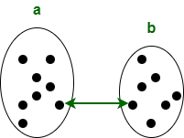
2. Complete Linkage
Complete linkage clustering generally yields clusters that are well segregated and compact. The distance between the two clusters is defined as the longest distance between two data points in each cluster.
L(a , b) = max(D(x_{ai} , x_{bj}))

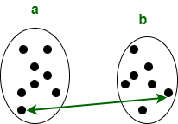
3. Simple Average
The simple average algorithm defines the distance between clusters as the average distance between each of the members, weighted so that the two clusters have an equal influence on the final output.
L(a , b) = T_{ab} / ( N_{a} * N_{b})
T_{ab}: The sum of all pairwise distances between the two clusters.
N_{a and Nb}: The sizes of the clusters a and b, respectively.
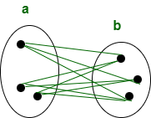

Distance Metrics
- Euclidean (most common)
- Manhattan
- Cosine (text data)

Why Scaling is Mandatory
Because distance is used:
- Large-scale features dominate
- Always apply StandardScaler / MinMaxScaler

Advantages
✔ No need to predefine K
✔ Highly interpretable
✔ Dendrogram gives insights
Disadvantages
❌ Computationally expensive (O(n²))
❌ Not suitable for large datasets
❌ Sensitive to noise

3️⃣ Dendrograms 🌳 (Heart of Hierarchical Clustering)
What is a Dendrogram?
A dendrogram is a tree diagram that shows:
- How clusters merge
- At what distance they merge
Example of a dendrogram:
Suppose we have six clusters: P, Q, R, S, T, and U. Cluster Hierarchy Dendrogram of these six observations shown on the scatterplot is:
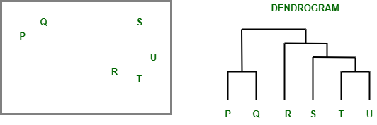Dendrogram from the given scatterplot
Parts of a dendrogram:
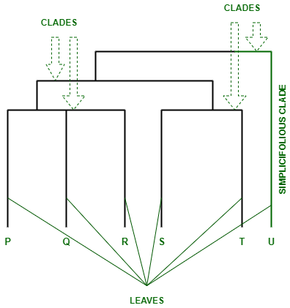Parts of a Dendrogram
- The branches of the dendrogram are called the Clades. These clades are arranged according to how similar or dissimilar they are.
- Each clade of the dendrogram has one or more leaves. P, Q, R, S, T, and U are leaves of the dendrogram:
  - Triple (trifolious): P, Q, R
  - Double (bifolius): S, T
  - Single (simplicifolius): U

How to Read a Dendrogram
Axes
- X-axis → Data points
- Y-axis → Distance / dissimilarity

Interpretation Rules
- Vertical line length = distance
- Large vertical jump = very different clusters
- Horizontal cut determines number of clusters

How to Choose Number of Clusters
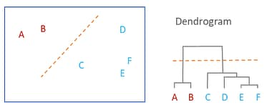
Golden Rule ⭐
Cut the dendrogram just before the largest vertical distance jump
Cluster Count Rule
Number of clusters = number of vertical branches crossed by the cut

“However, dendrograms alone cannot determine the optimal number of clusters, so this choice must be validated using silhouette analysis, stability testing, or domain knowledge.”

Why Dendrograms Are Powerful
- Visual explanation
- Business-friendly
- Justifies cluster choice

Interview Tip
“I selected the number of clusters by cutting the dendrogram at the point of maximum distance gap.”

4️⃣ DBSCAN (Density-Based Spatial Clustering)
What is DBSCAN?
DBSCAN groups data based on density, not distance between centroids.
It finds:
- Dense regions → clusters
- Sparse regions → noise/outliers
- 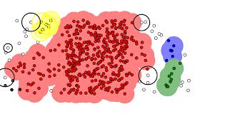

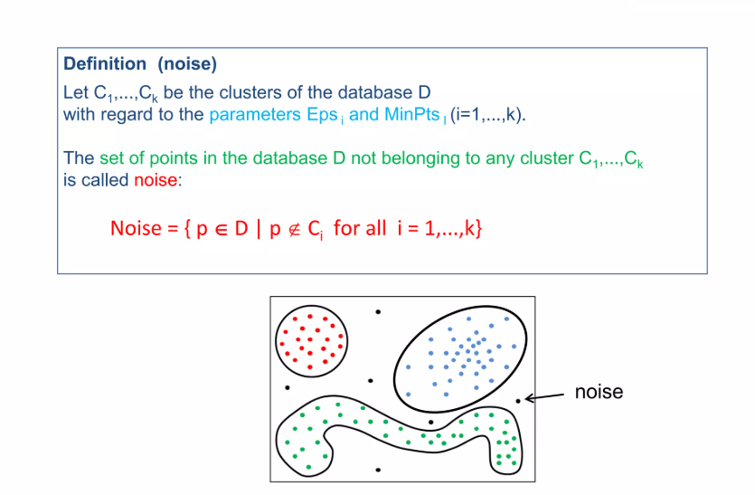
Core Concepts (MUST KNOW)
1. ε (Epsilon)
- Radius around a point
2. MinPts
- Minimum points inside ε to form a cluster

Preliminary Definitions
DBSCAN determines the density of an area based on two parameters that are provided to the algorithm:
- Epsilon (ϵ): The radius of the neighborhood around a data point.
- MinPts (Minimum Points): The minimum number of data points required to be within the ϵ-radius of a given point.
Based on these two parameters, the algorithm differentiates between three types of data points:
- Core Point: A data point that has at least MinPts points within ϵ distance (including itself).
- Border Point: A data point that has fewer than MinPts within ϵ distance, but lies within an ϵ distance of a core point.
- Noise Point (Outlier): Any data point that is not a core or border point.
The following figure illustrates these definitions:
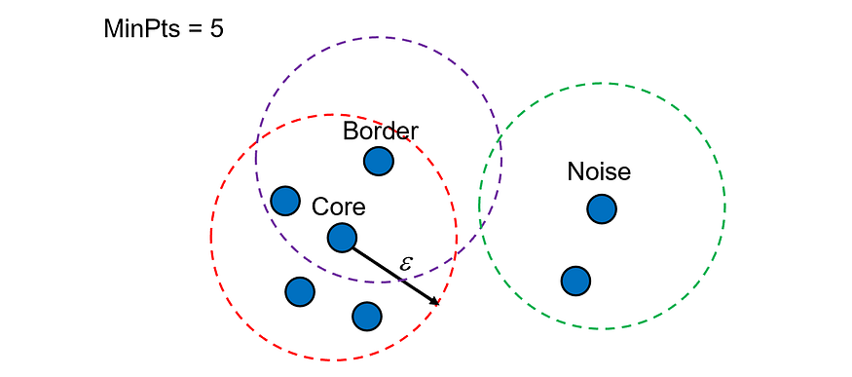

Point Types
Type | Meaning
Core point | ≥ MinPts in ε
Border point | < MinPts but near core
Noise | Not reachable

DBSCAN Algorithm
- Pick a point
- Check neighbors within ε
- If ≥ MinPts → start cluster
- Expand cluster
- Mark noise otherwise

Advantages
✔ No need to specify number of clusters
✔ Detects arbitrary shapes
✔ Handles outliers naturally

Disadvantages
❌ Hard to choose ε
❌ Struggles with varying densities
❌ Not ideal for high-dimensional data

When to Use DBSCAN
- Outlier detection
- Spatial data
- Non-spherical clusters
- Noise-heavy datasets

Applications
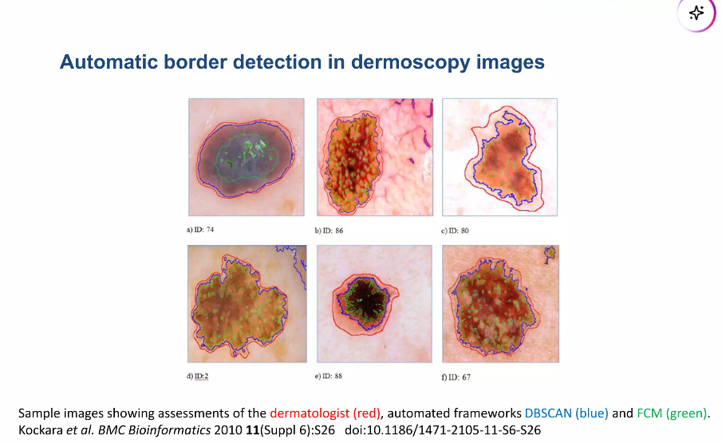

5️⃣ Agglomerative vs DBSCAN (INTERVIEW FAVORITE)
Feature | Agglomerative | DBSCAN
Needs K | ❌ | ❌
Handles noise | ❌ | ✅
Cluster shape | Mostly spherical | Arbitrary
Interpretability | High | Medium
Dendrogram | ✅ | ❌
Large datasets | ❌ | ✅

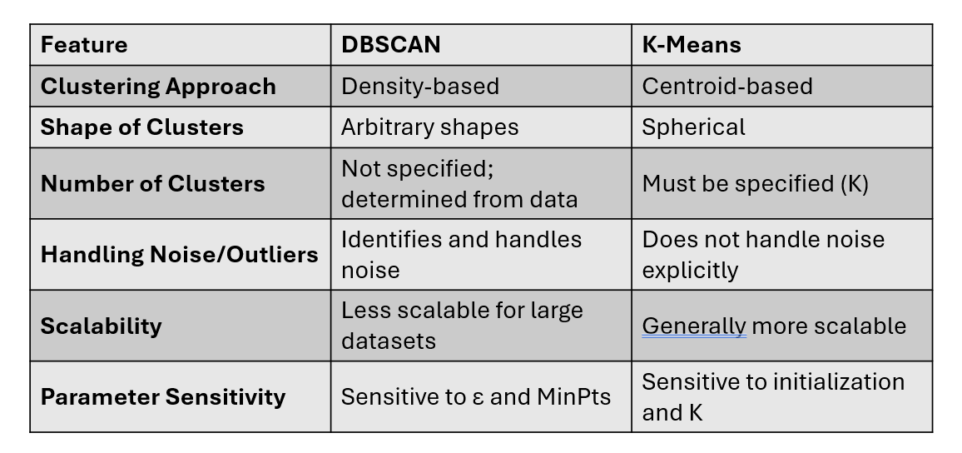

6️⃣ When to Use What (Decision Guide)
Use Agglomerative When:
✔ Dataset is small/medium
✔ Interpretability is important
✔ You want hierarchy
✔ Business explanation needed
Use DBSCAN When:
✔ Dataset has noise/outliers
✔ Cluster shapes are irregular
✔ Spatial or geo data
✔ Unknown cluster count

7️⃣ Common Interview Questions & Answers
Q1. Why Agglomerative over K-Means?
No need to predefine K and provides hierarchy via dendrogram.
Q2. Why Ward linkage?
It minimizes intra-cluster variance, producing compact clusters.
Q3. Why scaling is important?
Distance-based algorithms are scale-sensitive.
Q4. Can DBSCAN find number of clusters?
Yes, automatically based on density.

8️⃣ One-Page Summary (Cheat Sheet)
Hierarchical Clustering
- Tree-based clustering
- Interpretable
Agglomerative
- Bottom-up
- Ward + Euclidean best
Dendrogram
- Visual cluster hierarchy
- Cut before biggest jump
DBSCAN
- Density-based
- Handles noise
- No K needed

